Assignment 6

1. Design an ER diagram for an application that models a car-insurance company whose customers own one or more cars each. Analyze the requirements by identifying the entities, attributes, relationships, keys, constraints etc. Apply extended entity-relationship features to the design. Defend your design with proper assumptions and justifications. Map the ER model into a relational model.

**ER**

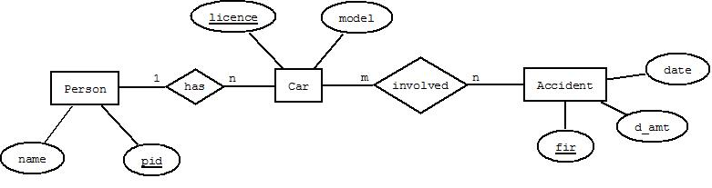

**Relational Model**

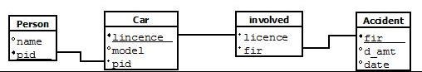

**Assumptions**

* **A person can have one or more cars**
* **A car must have licence which is used as primary key**
* **Cardinaility between car and accident is m:n**

1. Create tables, populate with data and construct queries (advanced) in SQL to extract information from the car insurance company’s database.Consider a car-insurance company whose customers own one or more cars each. Each car has associated with it zero to any number of recorded accidents.

**CREATE TABLES:**

create table person ( pid number(10) primary key, name varchar(20) );



create table car ( licence_no varchar(20) primary key, model varchar(20) not null, pid number(10) references person(pid) on delete cascade );



create table accident (fir varchar2(20) primary key, acc_date date not null, d_amt number(12,2));



create table involved (licence varchar2(20) references car(licence_no) on delete cascade, fir varchar2(20) references accident(fir) on delete cascade );



1. Enter at least 5 sets of records in each table form created in part (ii).

**INSERT DATA IN TABLES:**

insert into person values( 9069, 'apurba maity');  
insert into person values( 9065, 'soumyakanti banerjee');

insert into person values( 9074, 'swaraj paul');  
insert into person values( 9089, 'sourish pal');

insert into person values( 9060, 'soumya deep mandal');

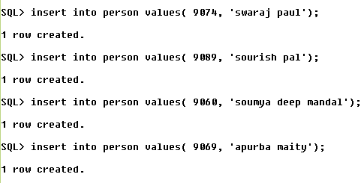

insert into car values('WB3f001','ferrari',9069);

insert into car values('WB3f002','honda',9065);

insert into car values('WB3f003','hyundai',9074);

insert into car values('WB3f004','mitshibushi',9060);

insert into car values('WB3f005','honda',9069);

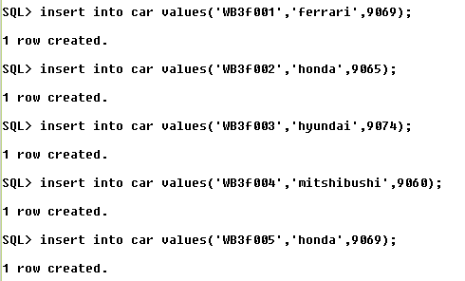

insert into accident values('FIR001', '12-JAN-2001',20000);

insert into accident values('FIR271', '12-DEC-2010',11000);

insert into accident values('FIR002', '12-JAN-2011',2000);

insert into accident values('FIR003', '12-JUN-2012',120000);

insert into accident values('FIR004', '12-JAN-2011',220000);

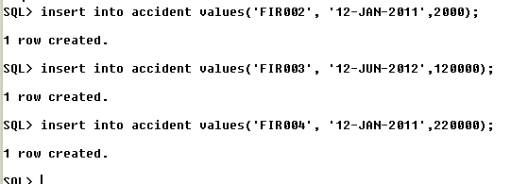

insert into involved values ('AIBPC2010', 'FIR271');

insert into involved values (‘WB3f001', 'FIR001');

insert into involved values (‘WB3f004', 'FIR004');

insert into involved values (‘WB3f001', 'FIR002');

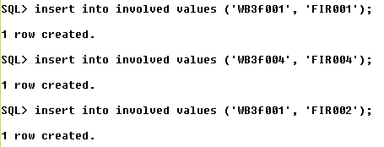

iv. Write and run the following SQL queries for your database:

1. Find the total number of people who owned cars that were involved in accidents in 2010.

* select * from car where licence_no in ( select i.licence from involved i join accident a on i.fir=a.fir and extract(year from a.acc_day)=2010)

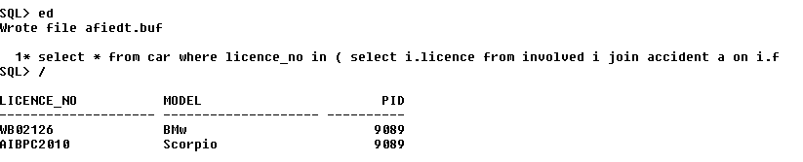

1. Find the number of accidents in which the cars belonging to “XYZ” were involved.

* select * from car c join involved i on c.licence_no=i.licence and c.pid in (select pid from person where name='XYZ');

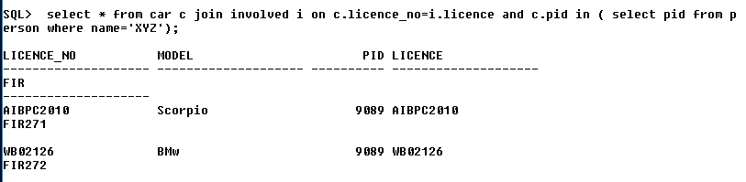

1. Add a new accident to the database; assume any values for required attributes.

* insert into accident values ( 'FIR273', '12-feb-2011', 2000);

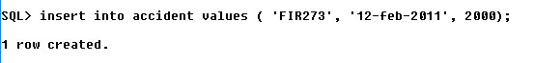

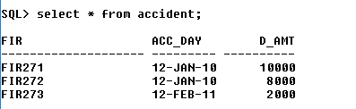

1. Delete the model ‘Scorpio belonging to “ABC”.

=> delete from car where model='scorpio' and pid = (select pid from person where name='ABC');

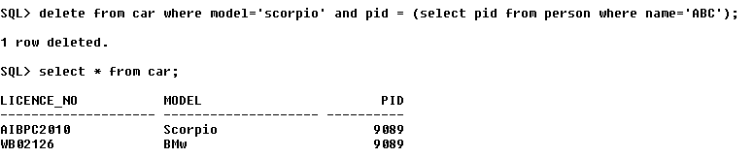

1. Update the damage amount for the car with license number “AIBPC2010” in the accident with report number “FIR271” to Rs. 5000.

* update accident set d_amt=5000 where fir in ( select a.fir from accident a join involved i on a.fir  
  =i.fir and i.licence='AIBPC2010' and i.fir='FIR271');

